SIMATS ENGINEERING
ASSESSMENT TOOL 2
NAME: Gurram Roshitha
REG NO: 192373027
COURSE NAME: INTERNET PROGRAMMING
COURSE CODE: CSA43

COURSE OUTCOME COVERED
CO -2 : Apply CSS layout and styling techniques to create visually appealing and
responsive web interfaces, and use JavaScript to enable interactive client-side behavior.
(L3)
Assessment Tool : Design Task
Weightage: 20%

QUESTIONS: Total Marks: 20

Question 1: Responsive Navigation Bar Design - Marks(4)
Suppose that an e-commerce website requires a responsive navigation bar that adapts across desktop, tablet, and mobile devices.
- Identify key components required in a navigation bar for an e-commerce website.
- Design a responsive navigation bar using appropriate CSS techniques.
- Demonstrate how the navigation adapts to smaller screens (e.g., hamburger menu).
- Evaluate the usability and suggest improvements for better user experience.

<!DOCTYPE html>
<html lang="en">
<head>
<meta charset="UTF-8">
<meta name="viewport" content="width=device-width, initial-scale=1.0">
<title>Responsive Navigation Bar</title>

<style>

*{ margin:0; padding:0; box-sizing:border-box; font-family:Arial, sans-serif;
}

body{ background:#f4f4f4;
}

.navbar{ background:#333; color:white; display:flex; justify-content:space-between; align-items:center; padding:15px 20px;
}

.logo{ font-size:24px; font-weight:bold;
}

.menu{
display:flex;
}

.menu a{
color:white; text-decoration:none; padding:10px 15px;
}

.menu a:hover{ background:#555; border-radius:5px;
}

.icon{ display:none; font-size:28px; cursor:pointer; }

/* Mobile View */
@media(max-width:768px){

.menu{
display:none; flex-direction:column; width:100%; background:#333; position:absolute; top:60px; left:0;
}

.menu.show{
display:flex; }

.menu a{ padding:15px; border-top:1px solid #555;
}

.icon{ display:block;
}

}

</style>
</head>

<body>

<nav class="navbar">

<div class="logo">ShopEasy</div>

<div class="menu" id="menu">
<a href="#">Home</a>
<a href="#">Products</a>
<a href="#">Categories</a>
<a href="#">Cart</a>
<a href="#">Login</a>
</div>

<div class="icon" onclick="toggleMenu()">☰</div>

</nav>

<script>

function toggleMenu(){ document.getElementById("menu").classList.toggle("show"); }

</script>

</body>
</html>
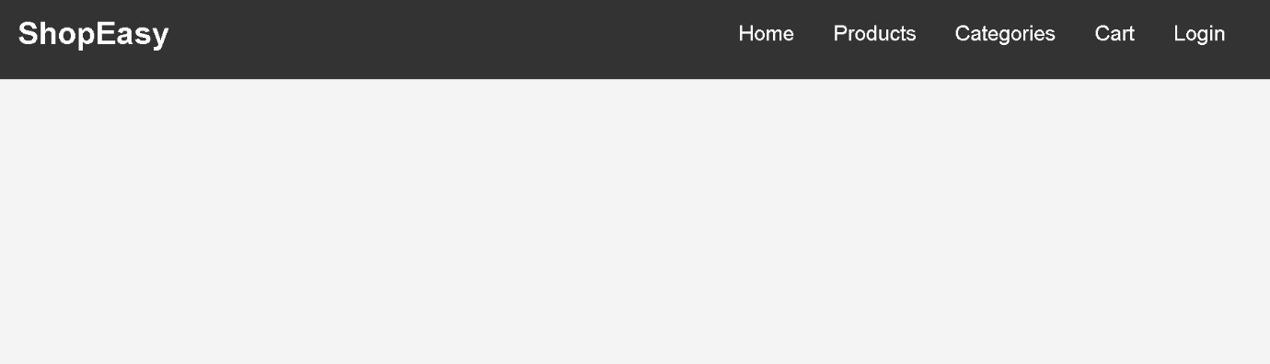

Question 2: Product Hover Effect - Marks(4)
Suppose that an e-commerce website wants to enhance user interaction through visual effects on product items.
- Identify suitable CSS properties for hover effects.
- Suggest appropriate CSS animation or transition for product interaction.
- Design a hover effect for a product card.
- Evaluate performance and user experience considerations.
<!DOCTYPE html>
<html lang="en">
<head>
<meta charset="UTF-8">
<meta name="viewport" content="width=device-width, initial-scale=1.0"> <title>Product Hover Effect</title>

<style>

*{ margin:0; padding:0; box-sizing:border-box; font-family:Arial, sans-serif;
}

body{ background:#f4f4f4; display:flex; justify-content:center; align-items:center; height:100vh;
}

.card{ width:250px; background:white; border-radius:10px; overflow:hidden; text-align:center; box-shadow:0 4px 8px rgba(0,0,0,0.2); transition:0.3s;
}

.card img{ width:100%; height:200px;
}

.card h2{ margin:15px 0;
}

.card p{ color:green; font-size:20px; margin-bottom:15px;
}

.card button{ margin-bottom:20px; padding:10px 20px; background:#007bff; color:white; border:none; border-radius:5px; cursor:pointer;
}

.card:hover{ transform:scale(1.05); box-shadow:0 8px 20px rgba(0,0,0,0.4);
}

.card button:hover{ background:#0056b3;
}

</style>
</head>

<body>

<div class="card">
<img src="https://via.placeholder.com/250x200" alt="Product">
<h2>Wireless Headphones</h2>
<p>$49.99</p>
<button>Buy Now</button>
</div>

</body>
</html>
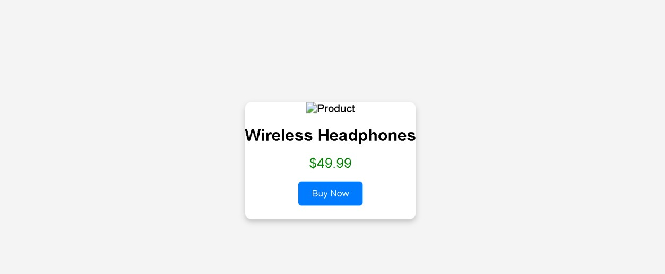

Question 3: Layout Selection (Flexbox vs Grid) - Marks(4)
Suppose that a dashboard layout needs to be designed for a web application.
- Identify layout requirements of a dashboard (rows, columns, alignment).
- Compare Flexbox and Grid based on layout needs.
- Choose the most suitable layout technique and justify your choice.
- Evaluate the scalability and responsiveness of the chosen approach.
<!DOCTYPE html>
<html lang="en">
<head>
<meta charset="UTF-8">
<meta name="viewport" content="width=device-width, initial-scale=1.0"> <title>Dashboard Layout Using CSS Grid</title>

<style>

*{ margin:0; padding:0; box-sizing:border-box; font-family:Arial, sans-serif;
}

body{
background:#f4f4f4;
}

.container{ display:grid; grid-template-columns:220px 1fr; grid-template-rows:70px auto 60px; grid-template-areas: "header header"
"sidebar main" "footer footer"; gap:10px; height:100vh; padding:10px;
}

.header{ grid-area:header; background:#007bff; color:white; display:flex; justify-content:center; align-items:center; font-size:24px;
}

.sidebar{ grid-area:sidebar; background:#333; color:white; padding:20px;
}

.sidebar ul{ list-style:none;
}

.sidebar li{ margin:15px 0;
}

.main{ grid-area:main; background:white; padding:20px;
}

.cards{ display:grid; grid-template-columns:repeat(3,1fr); gap:15px; margin-top:20px;
}

.card{ background:#e3f2fd; padding:30px; text-align:center; border-radius:8px;
}

.footer{ grid-area:footer; background:#007bff; color:white; display:flex; justify-content:center; align-items:center;
}

@media(max-width:768px){ .container{ grid-template-columns:1fr; grid-template-areas: "header"
"sidebar"
"main"
"footer";
}

.cards{ grid-template-columns:1fr;
}

}

</style>

</head>

<body>

<div class="container">

<div class="header">
Dashboard
</div>

<div class="sidebar">
<h3>Menu</h3>
<ul>
<li>Home</li>
<li>Users</li>
<li>Reports</li>
<li>Settings</li>
</ul>
</div>

<div class="main">
<h2>Welcome</h2>
<p>This is the dashboard content.</p>

<div class="cards">
<div class="card">Card 1</div>
<div class="card">Card 2</div> <div class="card">Card 3</div>
</div>

</div>

<div class="footer">
Copyright © 2026
</div>

</div>

</body>
</html>
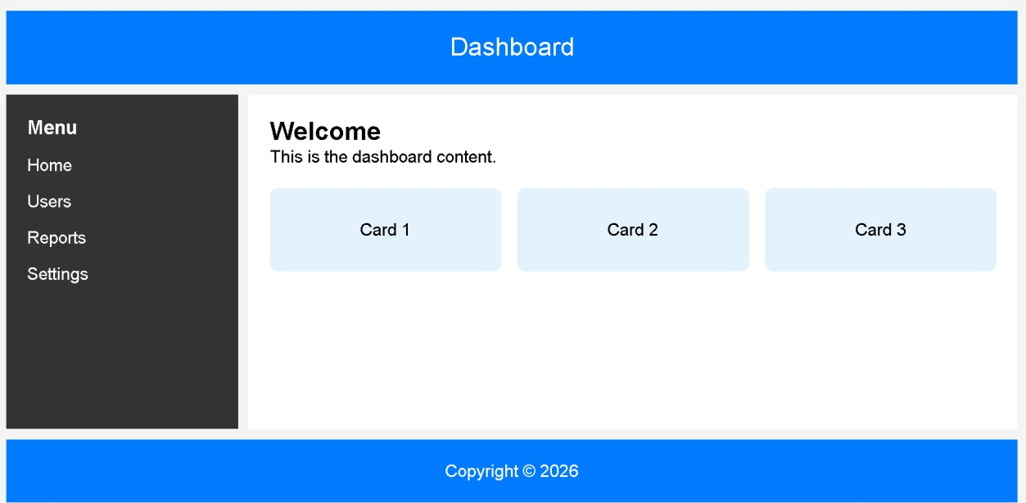

Question 4: Mobile-First Blog Layout - Marks(4)
Suppose that a blog page must be designed following a mobile-first approach.
- Identify key sections of a blog layout.
- Design a mobile-first layout using CSS.
- Demonstrate how the layout scales for larger screens using media queries.
- Evaluate accessibility and readability of the design.
<!DOCTYPE html>
<html lang="en">
<head>
<meta charset="UTF-8">
<meta name="viewport" content="width=device-width, initial-scale=1.0"> <title>Mobile-First Blog Layout</title>

<style>

*{ margin:0; padding:0; box-sizing:border-box; font-family:Arial, sans-serif;
}

body{ background:#f4f4f4;
}

/* Header */ header{ background:#333; color:white; text-align:center; padding:20px;
}

/* Navigation */ nav{ background:#555; text-align:center; padding:10px; }

nav a{ color:white; text-decoration:none; margin:10px; }

/* Mobile First Layout */ .container{ display:flex; flex-direction:column; padding:15px; }

article{ background:white; padding:20px; margin-bottom:15px; border-radius:8px; }

aside{ background:#dddddd; padding:20px; border-radius:8px; }

footer{ background:#333; color:white; text-align:center; padding:15px; margin-top:15px;
}

/* Tablet/Desktop View */
@media(min-width:768px){

.container{ flex-direction:row; gap:20px; }

article{ flex:3; }

aside{
flex:1; }

}

</style>

</head>

<body>

<header>
<h1>My Blog</h1>
</header>

<nav>
<a href="#">Home</a>
<a href="#">Articles</a>
<a href="#">About</a>
<a href="#">Contact</a>
</nav>

<div class="container">

<article>
<h2>Welcome to My Blog</h2>
<p>
This is a simple mobile-first blog page. The article section contains the main content of the blog.
</p>
</article>

<aside>
<h3>Recent Posts</h3>
<ul>
<li>HTML Basics</li>
<li>CSS Grid</li>
<li>JavaScript Events</li>
</ul>
</aside>

</div>

<footer>
<p>© 2026 My Blog. All Rights Reserved.</p>
</footer>

</body>
</html>
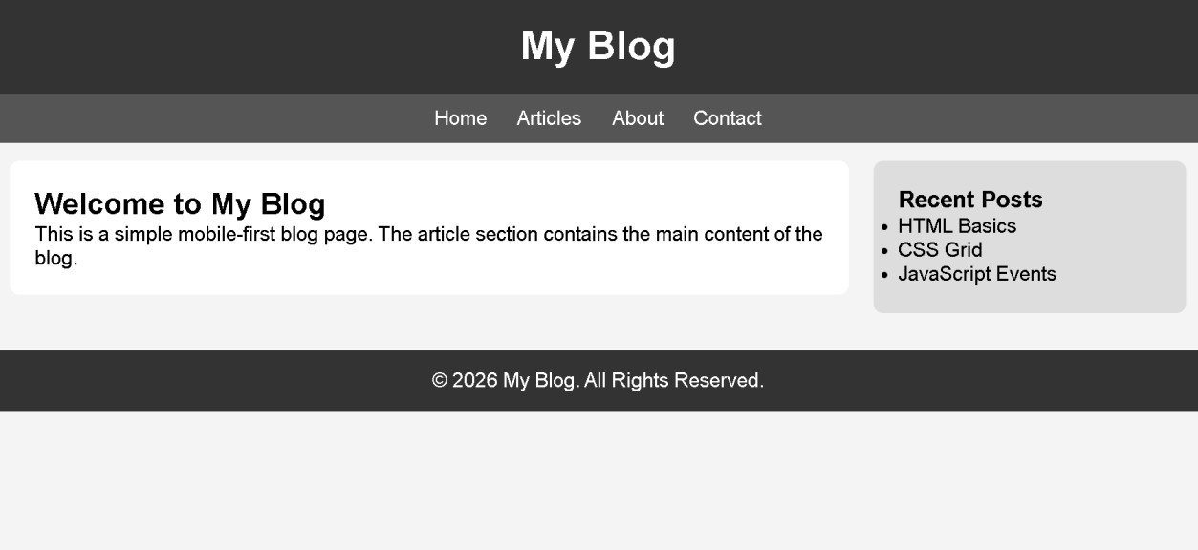

Question 5: JavaScript Event Handling for Dynamic Menu - Marks(4)
Suppose that a website includes a dynamic menu that responds to user interactions.
- Identify appropriate JavaScript events for menu interaction.
- Design event handling logic for menu toggle functionality.
- Implement interaction for user actions (click/hover).
- Evaluate performance and suggest improvements.
<!DOCTYPE html>
<html lang="en">
<head>
<meta charset="UTF-8">
<meta name="viewport" content="width=device-width, initial-scale=1.0">
<title>Dynamic Menu</title>

<style>

*{ margin:0; padding:0; box-sizing:border-box; font-family:Arial, sans-serif;
}

body{ background:#f4f4f4; text-align:center; padding:50px;
}

button{ padding:12px 25px; font-size:18px; background:#007bff; color:white; border:none; border-radius:5px; cursor:pointer;
}

button:hover{ background:#0056b3;
}

#menu{
display:none; width:200px; margin:20px auto; background:white; border:1px solid #ccc; border-radius:5px; box-shadow:0 4px 8px rgba(0,0,0,0.2);
}

#menu a{
display:block; padding:15px; text-decoration:none; color:black; border-bottom:1px solid #ddd;
}

#menu a:hover{ background:#f0f0f0;
}

.show{
display:block;
}

</style>

</head>
<body>

<h2>Dynamic Menu Example</h2>

<button id="menuBtn">☰ Menu</button>

<div id="menu">
<a href="#">Home</a>
<a href="#">Products</a>
<a href="#">Services</a>
<a href="#">Contact</a>
</div>

<script>

let button = document.getElementById("menuBtn"); let menu = document.getElementById("menu");

button.addEventListener("click", function(){ menu.classList.toggle("show");
});

</script>

</body>
</html>
